**Micro:bit neopixel traffic light**

**Instructions**

1. You should have:
   1. 1 neo pixel light
   2. 3 jumper wires(colours do not matter ☺)
   3. 1 micro:bit
   4. 1 Raspberry Pi
2. Connect one wire to the pin 0 on the bottom of the microbit, the second wire to the 3v pin and the last wire to the gnd pin.
3. Pick up the neo pixel light. On the back you will see in and out connections. You will need to connect the wires to the “in” side:
   1. Connect the wire attached to the GND pin on the micro:bit to GND pin on the light (remember in side)
   2. Connect wire attached to the 3V pin on the micro:bit to 5V pin on the light (remember in side)
   3. Connect wire attached to the attached on GND pin on the micro:bit to GND pin on the light (remember in side)
4. Wiring done phew ☺
5. On the Pi click menu > programming > MuType in the code below
6. Click on the “repl” button to see any error messages
7. Connect your micro:bit to the pi via usb port
8. Check your code for mistakes
9. Click on the flash button to see it work its magic. If there is an error this will be shown in the repl. Flash again after corrections are made.

**Micro:bit neopixel traffic light code**

from microbit import *  
import neopixel  
  
# Setup the Neopixel strip on pin0 with a length of 1 pixels  
np = neopixel.NeoPixel(pin0, 1)  
  
while True:  
    np[0] = (255, 0, 0)#red  
    np.show()  
    sleep(1000)  
    np[0] = (255, 69, 0)#amber  
    np.show()  
    sleep(1000)  
    np[0] = (0,255,0)#green  
    np.show()  
    sleep(1000)

Extension create a disco:

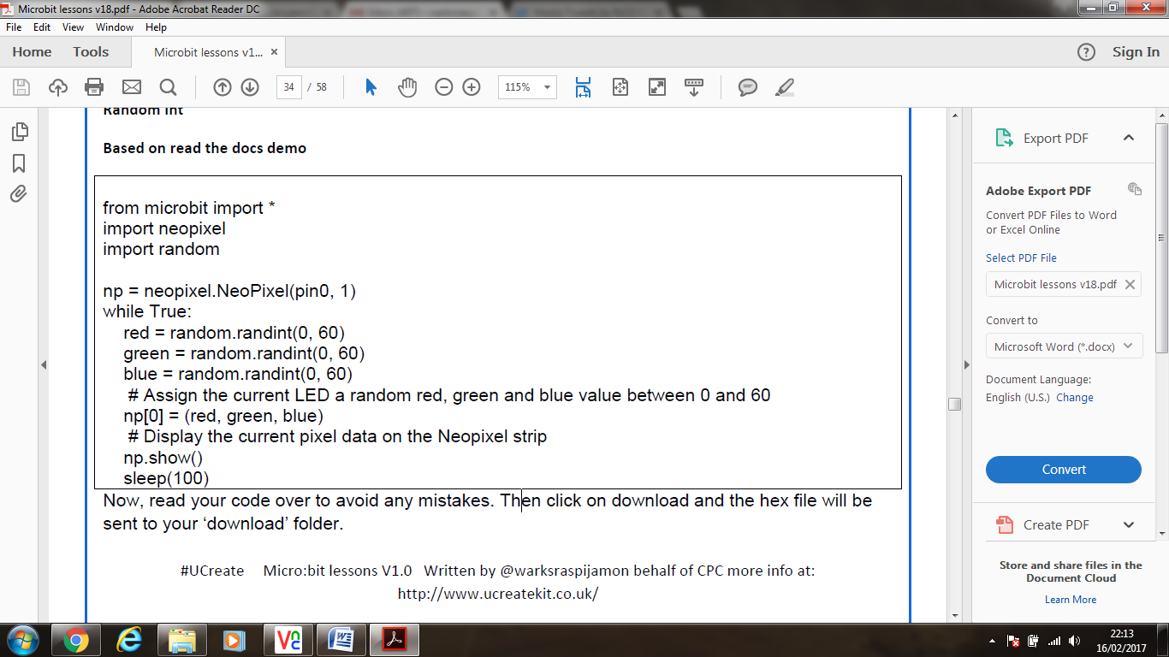

**Micro:bit triggered Minecraft traffic light**

1. Open up Mu by On the Pi click menu > programming > MuType in the code below:

**Micro:bit python code**

**from microbit import*  
import random  
REFRESH = 500  
Message = "On"  
def get_data():  
    if button_a.was_pressed() == True:  
        print(Message)  
  
def run():  
    while True:  
        sleep(REFRESH)  
        get_data()  
run()**

1. Click on the “repl” button to see any error messages
2. Connect your micro:bit to the pi via usb port
3. Check your code for mistakes
4. Click on the flash button to see it work its magic. If there is an error this will be shown in the repl. Flash again after corrections are made.
5. If you press the “a” button on the micro:bit then the word “On” should display in Repl
6. Close Mu

**Minecraft code instructions**

1. Open Python 2.7 by click menu > programming > python 2.7
2. Load a premade python script by clicking File > open > scroll across to find the “desktop” folder > locate the “mctllights.py” file > click open
3. In the code locate the section that says

“**#type your code here==============================**”

Type in the code below:

**Python code**

**#type your code here==============================  
    while True:  
  
        Message = read_microbit_data()  
        if Message == True:  
            x,y,z = mc.player.getTilePos()  
            mc.postToChat("Start Traffic lights")  
            time.sleep(1)  
            mc.setBlock(x+10, y-1, z, 35,14)#red  
            mc.setBlock(x+10, y-2, z, 35,15)#amber  
            mc.setBlock(x+10, y-3, z, 35,15)#green  
            time.sleep(1)  
            mc.setBlock(x+10, y-1, z, 35,15)#black  
            mc.setBlock(x+10, y-2, z, 35,4)#amber  
            mc.setBlock(x+10, y-3, z, 35,15)#black  
            time.sleep(1)  
            mc.setBlock(x+10, y-1, z, 35,15)#black  
            mc.setBlock(x+10, y-2, z, 35,15)#amber  
            mc.setBlock(x+10, y-3, z, 35,5)#green  
            time.sleep(1)**#your code stops here  
  
4. Save the file

5. Open up minecraft by going menu > games > minecraft

6. Open an existing world

7. Press tab on the keyboard and go back to python and press f5 to run your code ensure that the microbit is plugged into the usb port

8. Press the a button on the micro:bit and have minecraft visible you should see a traffic light sequence of blocks appear in front of you.

9. Congratulations ☺